**Course:** ENSF 337 – Fall 2020

**Lab #:** Lab 3

**Instructor:** M. Moussavi

**Student Name:** Quentin Jennings

**Lab Section:** B03

**Submission Date:** 2020-10-04

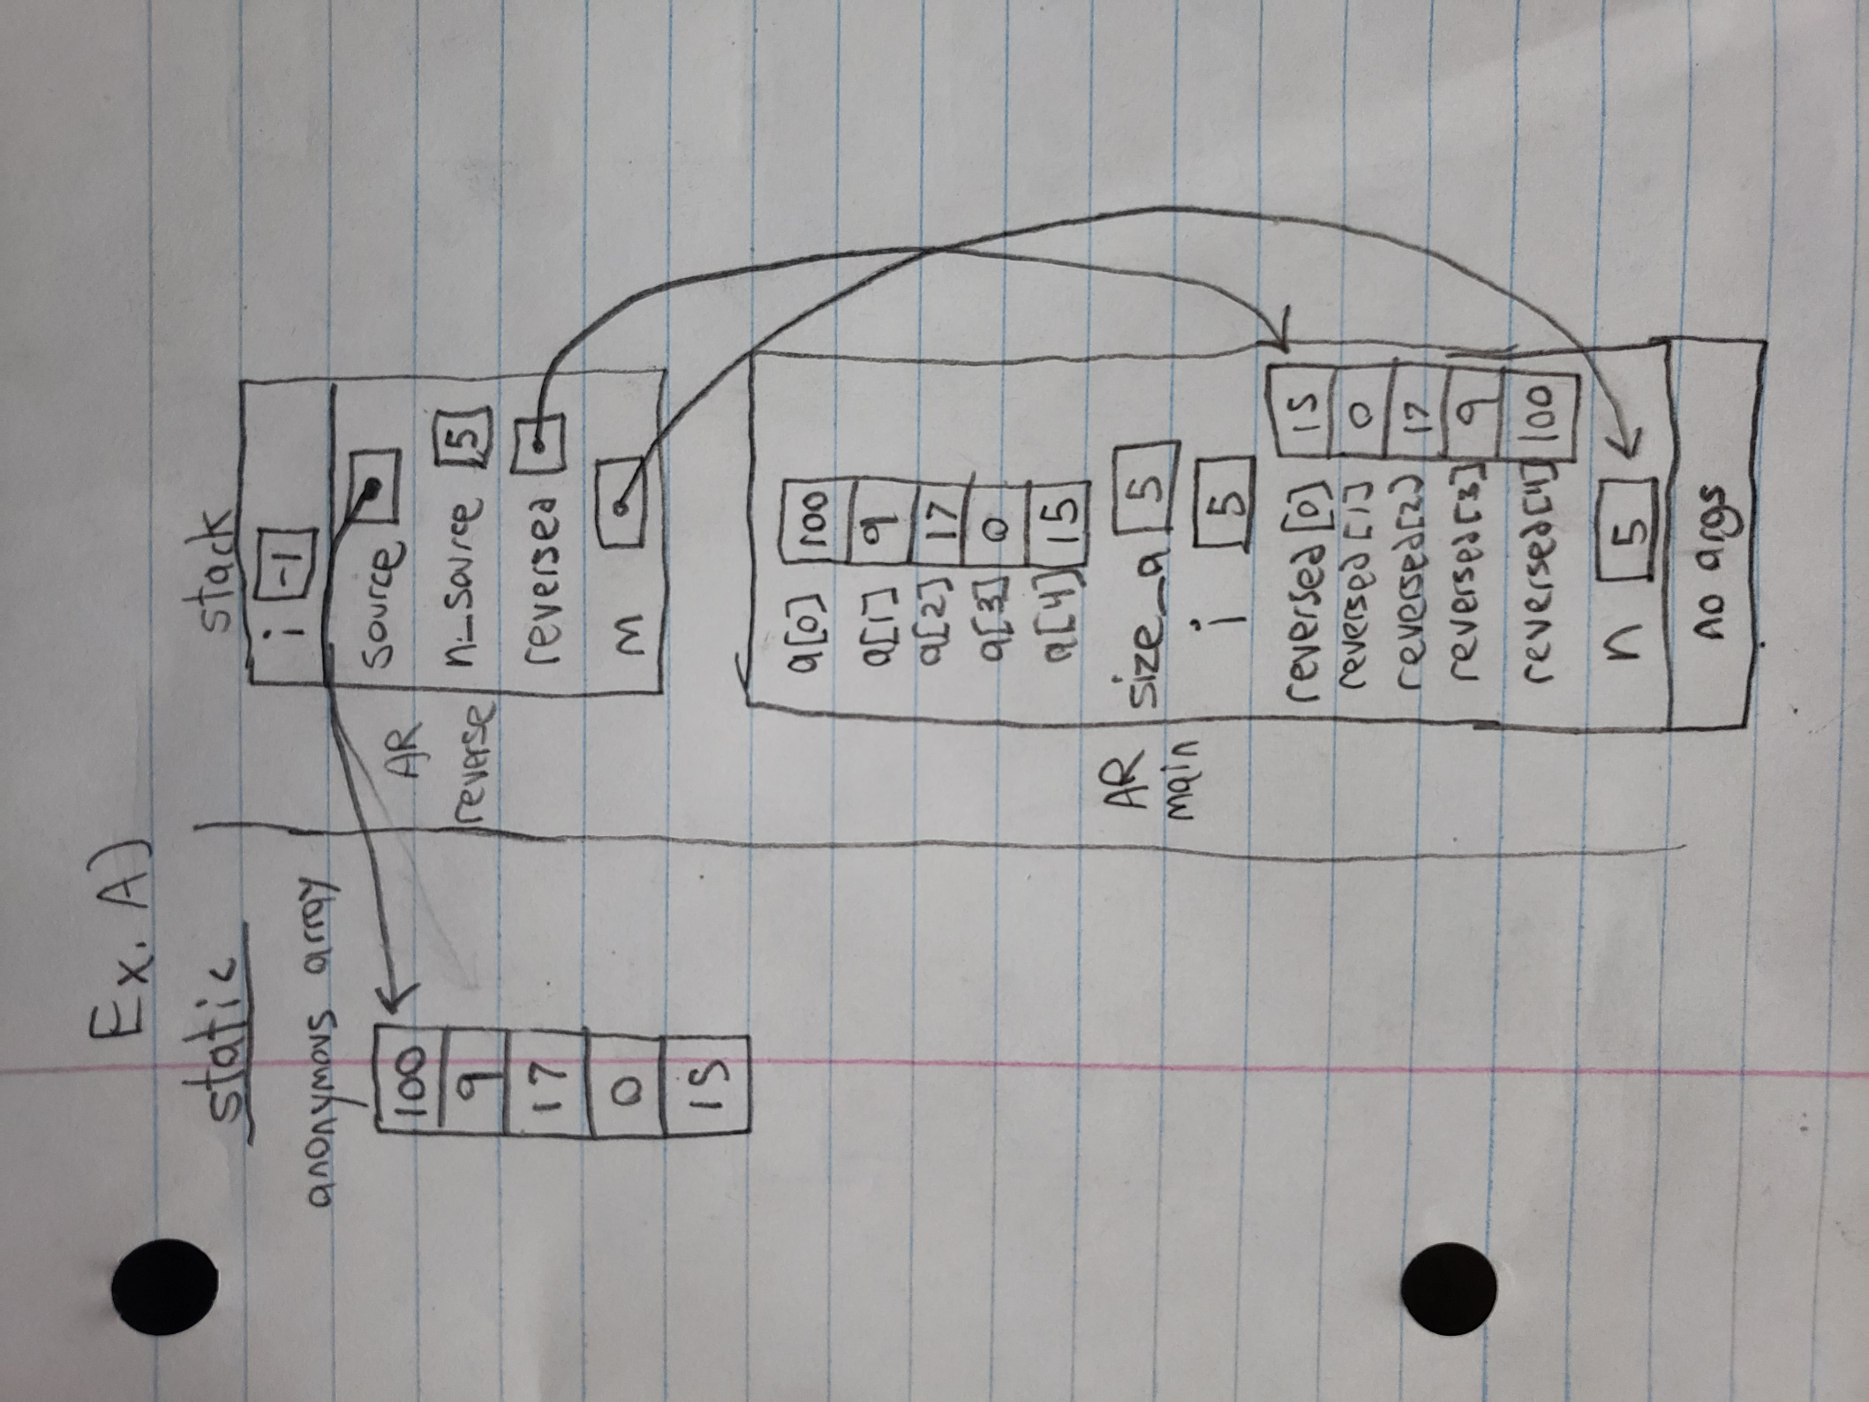

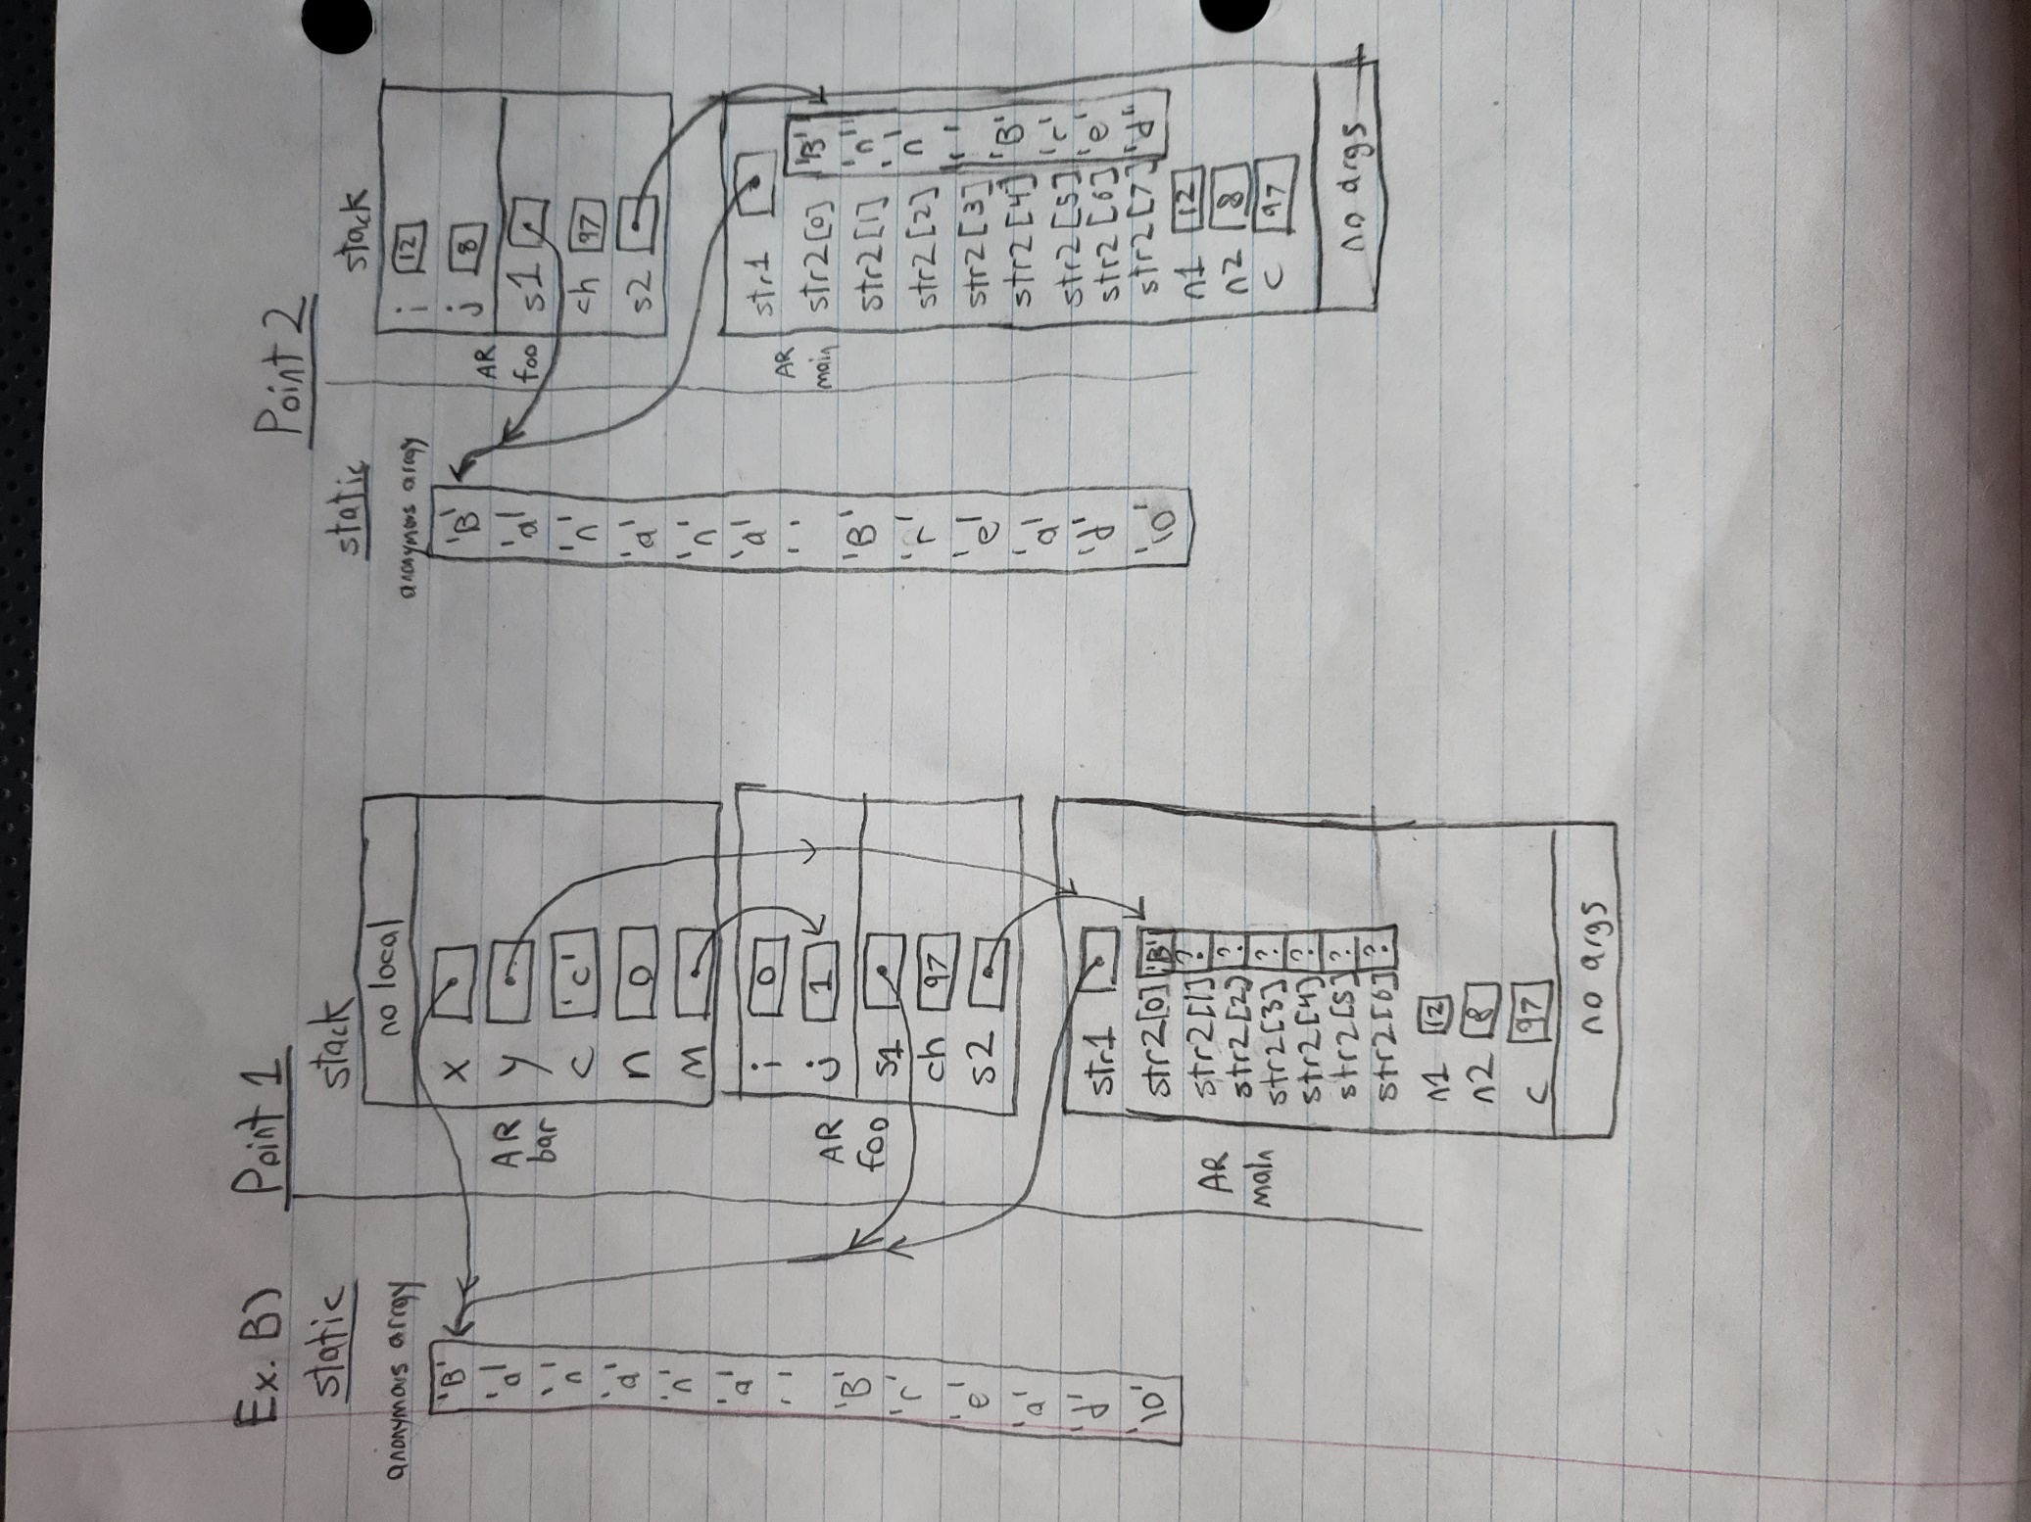

**Exercise C Output:**

Enter the number of rows (Max 20): 9

row 0: 1

row 1: 1 1

row 2: 1 2 1

row 3: 1 3 3 1

row 4: 1 4 6 4 1

row 5: 1 5 10 10 5 1

row 6: 1 6 15 20 15 6 1

row 7: 1 7 21 35 35 21 7 1

row 8: 1 8 28 56 70 56 28 8 1

**Exercise D Output:**

a has 5 elements: -10 9 -17 0 -15

negative elements from array a are as follows: -10 -17 -15

Now testing substring function....

Answer must be 1. substring function returned: 1

Answer must be 0. substring function returned: 0

Answer must be 1. substring function returned: 1

Answer must be 0. substring function returned: 0

Answer must be 1. substring function returned: 1

Answer must be 0. substring function returned: 0